**Analysis of the Correlation between Country’s Measurable Parameters and COVID-19**

**Athul Shibu,** 5th April 2020

***Abstract:*** *Italy has been hit particularly badly by the COVID-19 pandemic and has one of the highest fatality rates. High levels of intergenerational interaction in the country have been identified as a potential contributor to this. This report aims to find other such contributors into such poor results by concentrating on 5 very diverse countries and analysing their results.*

Europe and USA have seen a sudden surge in the number of infections, bringing the tally to over 420,000 cases worldwide and a staggering 18,900 fatalities. These estimates are slightly higher than those from World Health Organisation’s (WHO) reports, but still agree that the United States have the potential to be the new epicentre of the Pandemic due to a very large acceleration in the number of infections. This report aims to find other such possibilities by looking at the various contributing factors from an year before the start of the epidemic for the following 6 countries; Australia, India, Italy, France, South Korea and Canada. These countries were chosen for their relatively transparent government policies and for representing a specific demographic.

The dataset given has been modified to suit the needs of the analysis. The changes made are:

1. Data for specific countries have been extrapolated.
2. For countries that have been split into different regions, the sum total for each region per day has been taken as the total for each day.
3. A new dataset consisting only of the increases (or decreases) per day was made to analyse other trends. The reasons for creating new datasets from the existing ones will be explained under each parameter.

The following are the parameters with which the countries will be analysed for correlation; tourism, health budgets and average temperature. Finally, this paper will also analyse the impact of COVID-19 on the economies of some countries.

**Tourism:**

Tourism generally refers to travel for pleasure or business. It has grown into such a major industry that governments consider it a top priority and spend billions to attract tourists, maintain existing tourist destinations and provide services to both residents and tourists, enabling them to help each other out. Tourists, especially those that come for pleasure, closely interact with the locals. Foreign tourists could thus be a potential carrier for viruses, which they then pass on to locals who aid in spreading of the virus throughout the nation.

**Hypothesis:** Countries with a high footfall of tourists must have a higher number of infections.

**Data:** France is the top Tourist destination in the world, with a total footfall of 90 million visitors in 2018. Italy is close behind at 63.2 million, the same year. Canada had 21 and South Korea had 15.35 million visitors. India and Australia have a smaller, but significant 8.89 and 8.5 million respectively.

**Analysis:** France has a very high number of tourists, and so does Italy. It is important to remember that these two countries share a border, and since they are a part of the European Union, fairly easy to travel from one to the other. So it is likely that their infections will be quite similar, but higher than the rest.

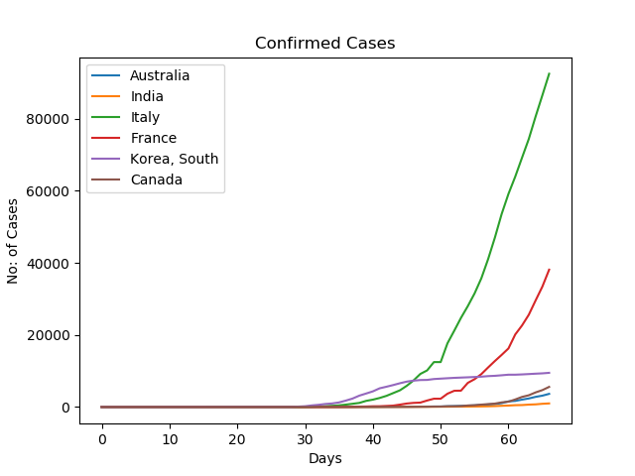

The graphs tell a similar story. Canada is a popular destination for students, hence it is likely that the data for tourists account for some students too. Also, in South Korea, K-Pop concerts are a favourite among tourists. A concert is attended by thousands of fans in densely packed stadiums, providing a fair medium for spread of infections. This explains why South Korea has a higher number of infections than Canada. Australia and India have similar count of visitors, which is shown in the graphs too.

**Verdict:** Tourism could be argued as a significant factor in the spread of Corona.

**Solutions:** Most countries have already started locking down. This has also resulted in visible signs of slowdown in the number of infections.

**Health Budget:**

Health budget here refers to the amount of money a country has invested in its Medical systems. Though it cannot be used as an absolute factor for measuring the health of the residents of the nation, especially since governments have started pumping in more and more funds in the wake of the pandemic, it can be used to assess the quality of the existing Medical system.

**Hypothesis:** Countries with a lower budget should show a higher increase in the number of infections per day.

**Data:** Italy spend 8.94% of their $1.935 trillion GDP for health care, putting them at a modest $173 billion. France and Canada are the big players in this department, with a $229 billion and $264 billion respectively. Australia spend a modest $104 billion while South Korea spend $56.8 billion. The real clincher though is India, who spend only $10 billion on its 1.339 billion population. So the per capita spending (in USD) of the countries is as follows; Australia - $5,002, Canada - $4,458, France - $4,263, Italy - $2,739, South Korea - $2,044 and India - $7.468.

So the graph should, if the hypothesis is correct, have a very high slope for India, and fairly similar for the rest (ordered in reverse of the above order best case scenario).

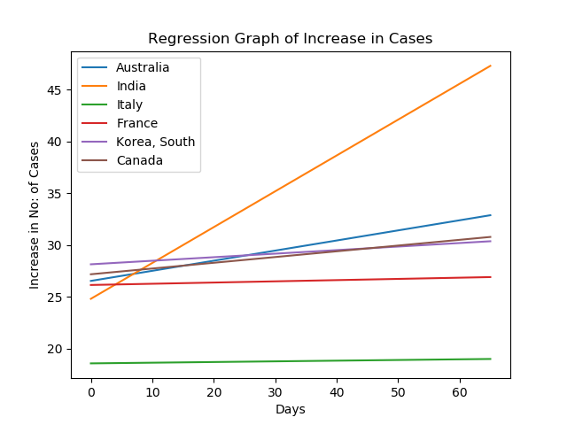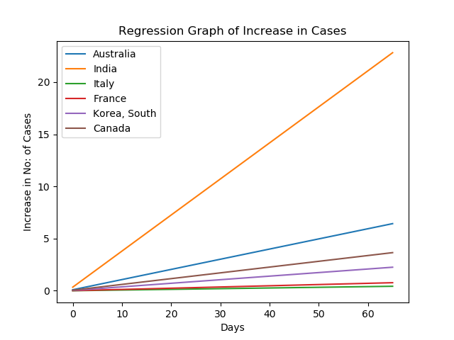

The first graph is a regression of the increase in cases from the day before the first case was detected. The second is the same, but without the ‘B-intercept’ (the first point on the Y-axis), to show the slope conveniently. While the prediction about India was spot on, the other countries do not hold up to the same logic. It can however be argued that India’s abysmal per capita value has effectively broken the curve, and that over a certain per capita value, effects start to get similar.

**Verdict:** While it cannot be used as a definitive factor, Health budgets do, to a certain extent, reflect the quality of Medical service, and hence the health of the nation as a whole.

**Solution:** India has infused another $22 billion, which is still too less, but this could be a start into revamping the whole Medical system. This will prove to be a good move, at least in the long run.

**Average Temperature:**

It is a scientifically contested fact that COVID-19 can be killed by high temperatures. Though no definitive proof has been given, the fact has spread like wildfire across social media. This is an example of an infodemic.

**Hypothesis:** Higher the temperature of the area, more likely is the chance of recovery.

**Data:** The dataset given is dated from 22nd January to 28th March. The mean of the daily mean temperatures in Italy in that time is 9.1 Celsius. For France, it could go down to 4 Celsius and Australia, 32 Celsius. In South Korea, the average itself is -3 Celsius and in Canada, it’s -5 Celsius. India’s average temperature is a surprising 36 Celsius. If the hypothesis is correct, regression graph of the number of cases of recovery will have a higher slope for India and Australia than for South Korea and Canada, with France and Italy falling in between (leaning towards the graphs of Canada and South Korea).

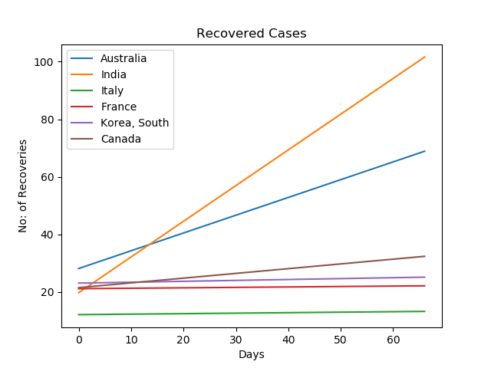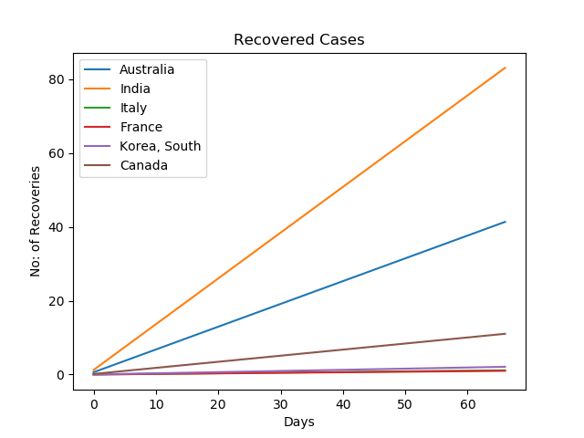

The Hypothesis seems to hold true for India and Australia, but not so much for the rest. From this, we can infer that temperature does play a role, albeit, one that is above a threshold value. This can be confirmed by using more countries with high enough average temperatures.

**Verdict:** There is no Linear correlation between Temperature and Recovery, but above a certain threshold value, it may have some correlation.

**Economic Impact:**

It is undoubted that COVID-19 has had a detrimental impact on the economy of the world, some countries more so than others. But it is not easy to assess the economic stability of a country. The closest we can come to assess it though, is by looking at the value of each country’s currency.

**Hypothesis:** Every country will experience a temporary dip in the values of their currencies.

**Data:** We will compare side-by-side the number of infections per day for each country. We will also look at the price of those country’s currencies during the same period (22nd January to 28th March, 2018).

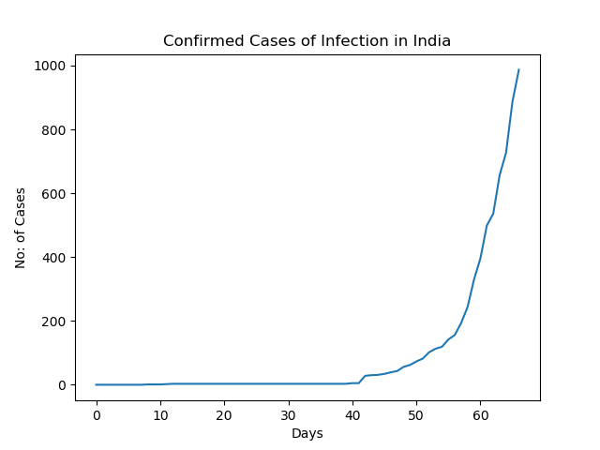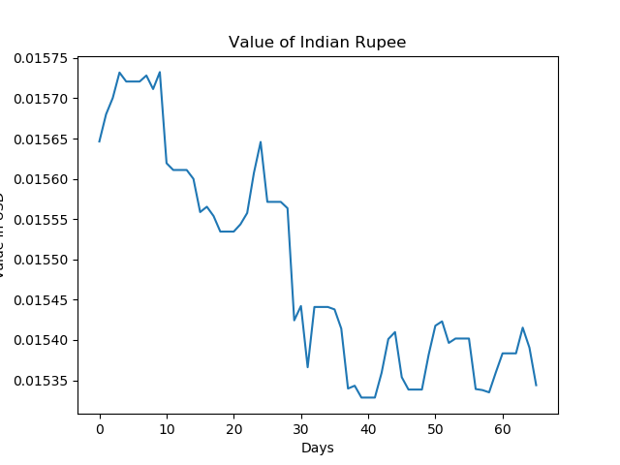

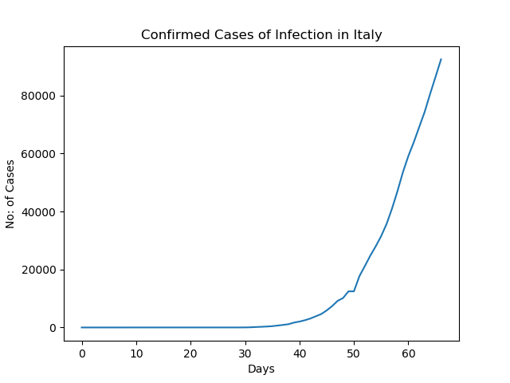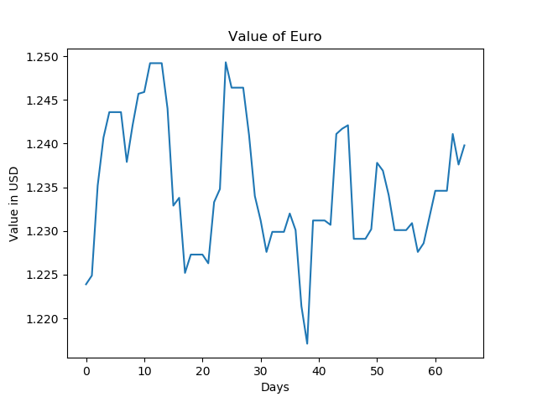

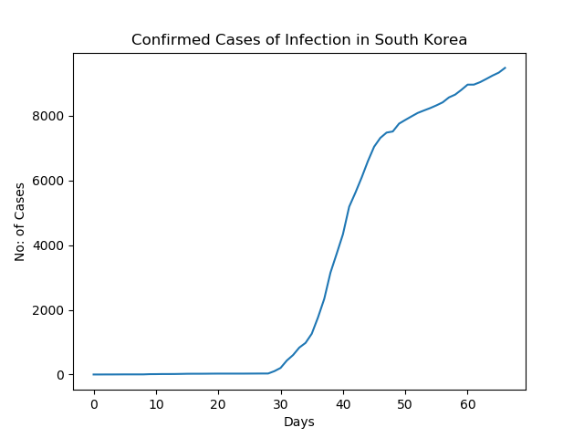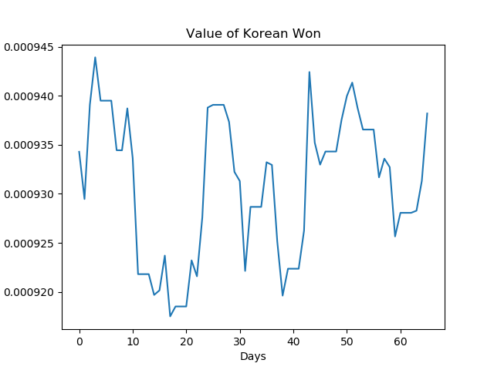

Many countries have seen a slight dip in the values of their currencies. But these graphs can’t show the real story, because they compare each currency to US Dollars, which itself has shown a drop in value.

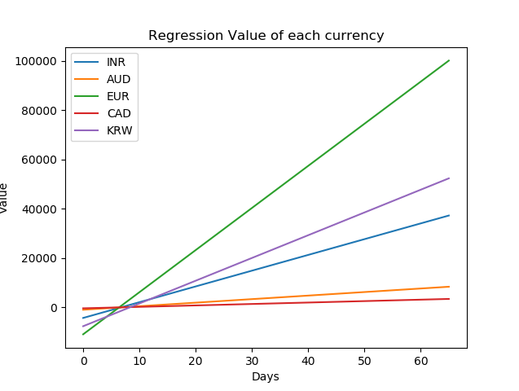

It shows that we need to mobilise scholars and Economic experts to analyse and rework the economic framework, and implement them together, or else face a recession and perish together.

**References:**

1. <https://www.google.com/>
2. <https://www.euronews.com/2020/03/19/coronavirus-latest-european-central-bank-launches-750-billion-pandemic-emergency-plan>
3. <https://www.theatlantic.com/international/archive/2020/03/india-coronavirus-covid19-narendra-modi/608896/>
4. <https://www.businessinsider.com/coronavirus-lifespan-on-surfaces-graphic-2020-3>
5. <https://www.macrotrends.net/countries/ITA/italy/healthcare-spending>